User Manual

Team NSA

Faris Hawamdeh

Dustin Fennessy

Nicholas Chard

Bradford SMith

Trae Watkins

Bikash Munikar

2014

Table of Contents

Introduction and Context 2

Users and Their Goals 2

Customer Kiosk 3

Startup Screen 4

Order Screen 5

Customize Screen 6

Customer Loyalty Screen 7

Language Screen 8

Manager Kiosk 9

Manager Order Screen 10

Manager Loyalty Account Screen 11

Assistant Managers Screen 12

Manager Store Inventory Screen 13

Manager Store Report Screen 14

Manager Menu Item Screen 15

Managers Component Screen 16

Manager Tool Screen 17

Corporate Kiosk 18

Corporate Stores Screen 19

Corporate Orders Screen 20

Corporate Loyalty Account Screen 21

Corporate Store Manager Screen 22

Corporate Reports Screen 23

Other Terminals 24

Kitchen Terminal Screen 25

Dining Area Terminal 26

# Introduction and Context

The purpose of the system is to take orders from customers and exchange payment without requiring an employee. The system will allow store managers to make changes to the menu and the store inventory. Loyalty accounts will be automatically administered by the system with the ability to save favorite orders as well as view previous orders.

The majority of food retailers still use a system that hasn’t changed which requires the businesses to hire employees specifically to take orders from customers. Employees have to spend unnecessary time at the end of each business day to manually count the day’s receipts and gross income. The extra employees needed to fill these cashier positions are extra costs to businesses that can be replaced by a computer kiosk. Store inventory is not kept track of in real time making it difficult for employees to anticipate an ingredient running out.

The proposed system will remove the requirement of having full time employees fill cashier positions reducing the business’ employees to managers and kitchen staff. The system will automatically keep track of and calculate each receipt and the store’s sales data each day. Corporate will be able to request accounting information from each store. Loyalty accounts can be created for customers visiting the business that automatically keeps track of progress towards loyalty rewards and stores favorite orders and previous orders.

## Users and Their Goals

The users of this system will be the customers of the store, the store managers, and corporate executives. The user interface will be simple and intuitive so that customers will not need prior experience using digital interfaces to understand the steps. The goal is to produce a system that will reduce the daily cost for businesses while still providing the same services to customers.

# Customer Kiosk

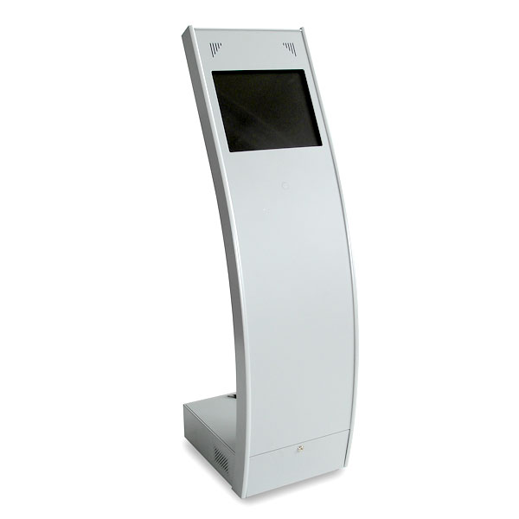

## Startup Screen

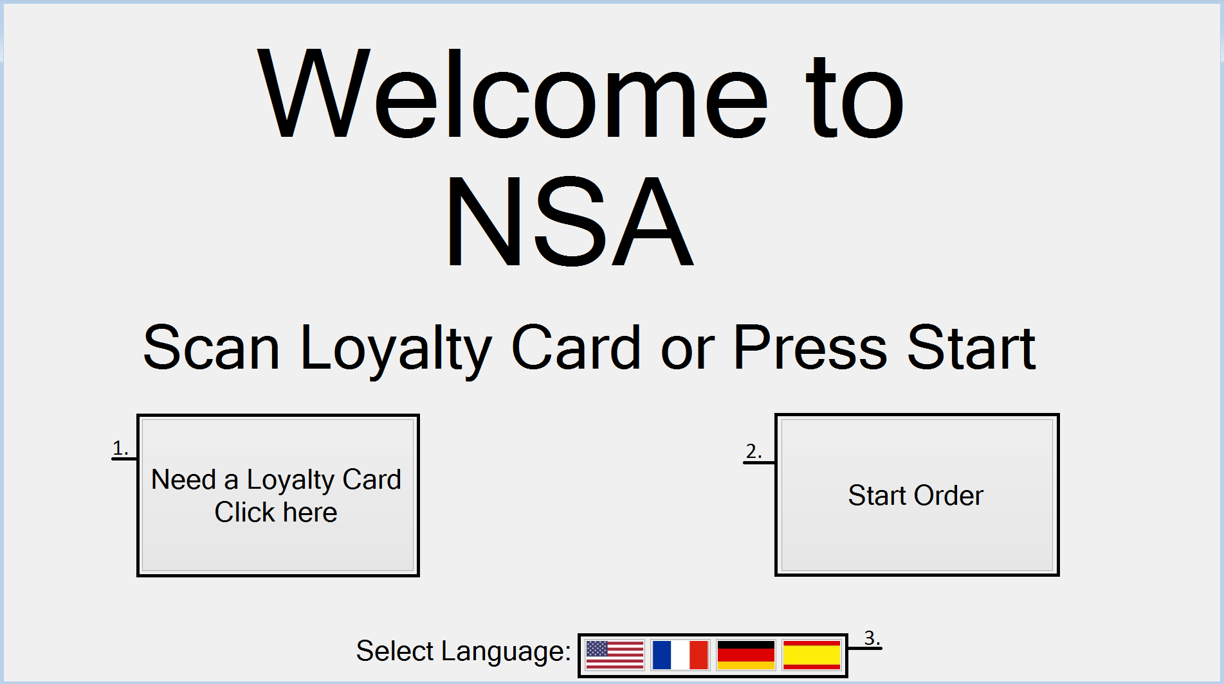

This screen is the first screen that the customer will see when he/she walks up to the terminal. The customer can scan his/her loyalty card to place an order with his/her loyalty account or press the start order button to place an order anonymously. The terminal will default to English on startup but the customer can select the language they are most comfortable with by pressing the corresponding country flag. If the customer does not have a loyalty account, the customer can click the sign up button to sign up for a loyalty account.

1. **Signup Button** – The signup button will take customers to the sign up page where they can fill out the loyalty account signup form to create their loyalty account.
2. **Start Order Button** – The Start Order button take the customer to the Order screen without logging into a loyalty account. Customers pick this option if they want to place an order anonymously.
3. **Language Buttons** – The row of buttons denoted by flags will change the language of all the text on the terminal to the language corresponding with the flag. The system supports 4 languages: English, French, German, and Spanish.
4. **Scan Loyalty Card** – The customer can scan their loyalty card on the card reader to log into their loyalty account. The customers pick this option if they want to place an order with their loyalty account.

## Order Screen

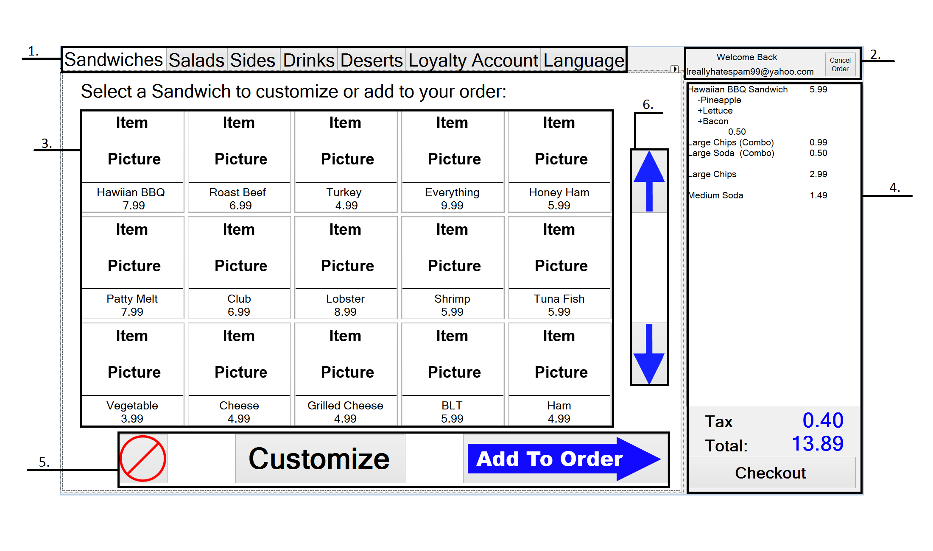

The order screen is the first screen that the customer sees after choosing to log in to their loyalty account or shop anonymously. The items available to purchase are displayed in a grid that can be scrolled up and down using the arrows to the right. The receipt is displayed on the right of the screen and automatically updates as items are added to the order. If the customer is logged into their loyalty account, the email address associated with the account is displayed at the top right along with a button to log out of the account.

1. **Navigation Tab** – The navigation tab will allow customers to move between different menus within the order screen by pressing the corresponding tab.
2. **Identity Widget** – The identity widget only appears when the customer has logged into their loyalty account. The widget allows users to cancel their order and log out of their account. The widget displays the email address that is associated with the loyalty account used to log in.
3. **Menu -** The menu contains buttons that the customer can select and add to their order. The buttons contain a picture of the item, the item name, and the item cost.
4. **Receipt Bar** – The receipt bar keeps track of the items the customer has added to their order and the cost of the item. The receipt bar will update automatically when new items are added to the order. When the customer is finished with their order, the customer presses the “Checkout” button that sends the customer to the payment screen.
5. **Menu Action Buttons** – The menu action buttons allow the customer to add menu items to the order using the “Add To Order” button. The “Customize” button allows customer to customize the menu item selected to make changes to the preset. The “Cancel” button will delete the order and return the customer to the startup screen.
6. **Scroll Arrows** – The scroll arrows allow the customer to scroll up and down the menu list.

## Customize Screen

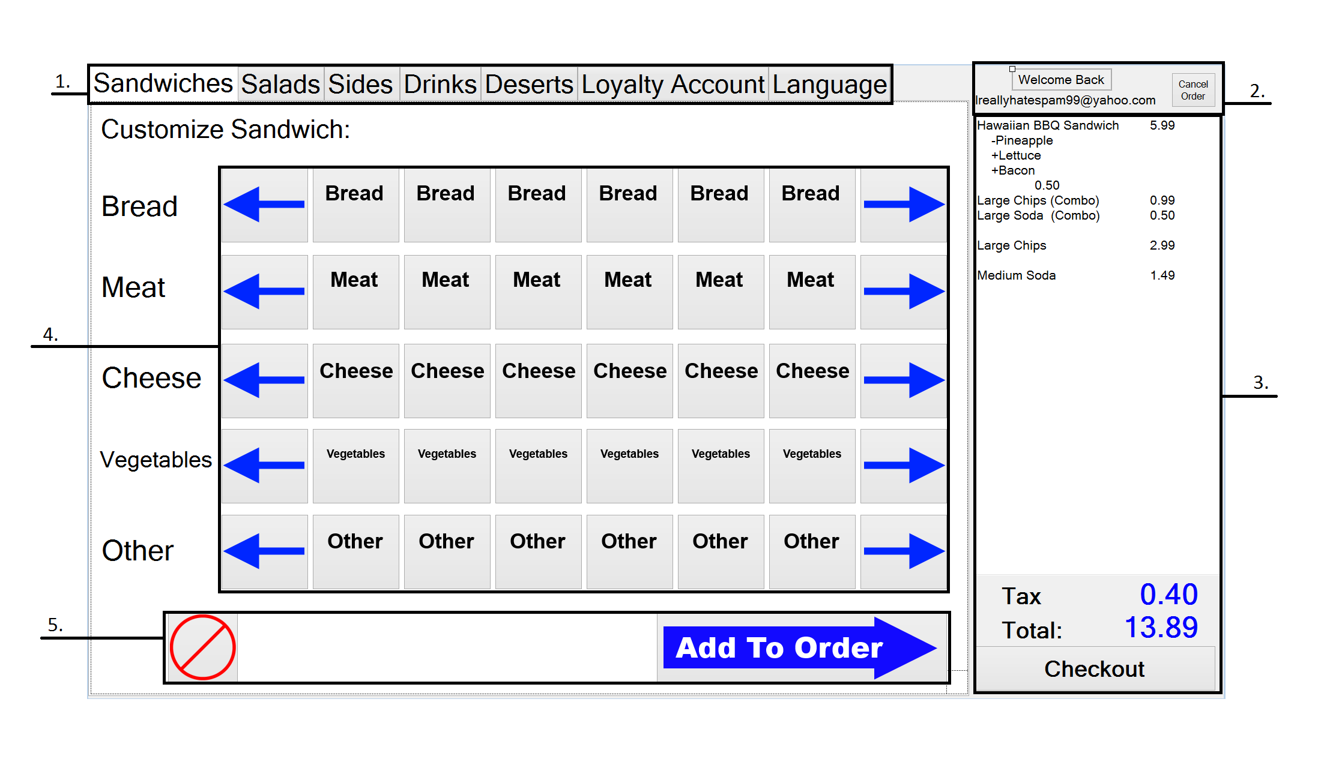

The customize screen is where the customer can choose all the components that go into their sandwich. The ingredients are listed in categories with arrows used to scroll through the list. When the customer is finished choosing their ingredients by pressing the pictures, the customer presses the “Add to Order” button and the item appears on the receipt to the right.

1. **Navigation Tab** – The navigation tab will allow customers to move between different menus within the order screen by pressing the corresponding tab.
2. **Identity Widget** – The identity widget only appears when the customer has logged into their loyalty account. The widget allows users to cancel their order and log out of their account. The widget displays the email address that is associated with the loyalty account used to log in.
3. **Receipt Bar** – The receipt bar keeps track of the items the customer has added to their order and the cost of the item. The receipt bar will update automatically when new items are added to the order. When the customer is finished with their order, the customer presses the “Checkout” button that sends the customer to the payment screen.
4. **Customize Menu** – The customize menu allows the customer to modify the various ingredients of the sandwich they picked. The buttons will have pictures of the item and the arrows can be used to view the ingredients that do not appear in the list.
5. **Menu Action Buttons** – The menu action buttons allow the customer to add menu items to the order using the “Add To Order” button. The “Cancel” button will delete the order and return the customer to the startup screen.

## Customer Loyalty Screen

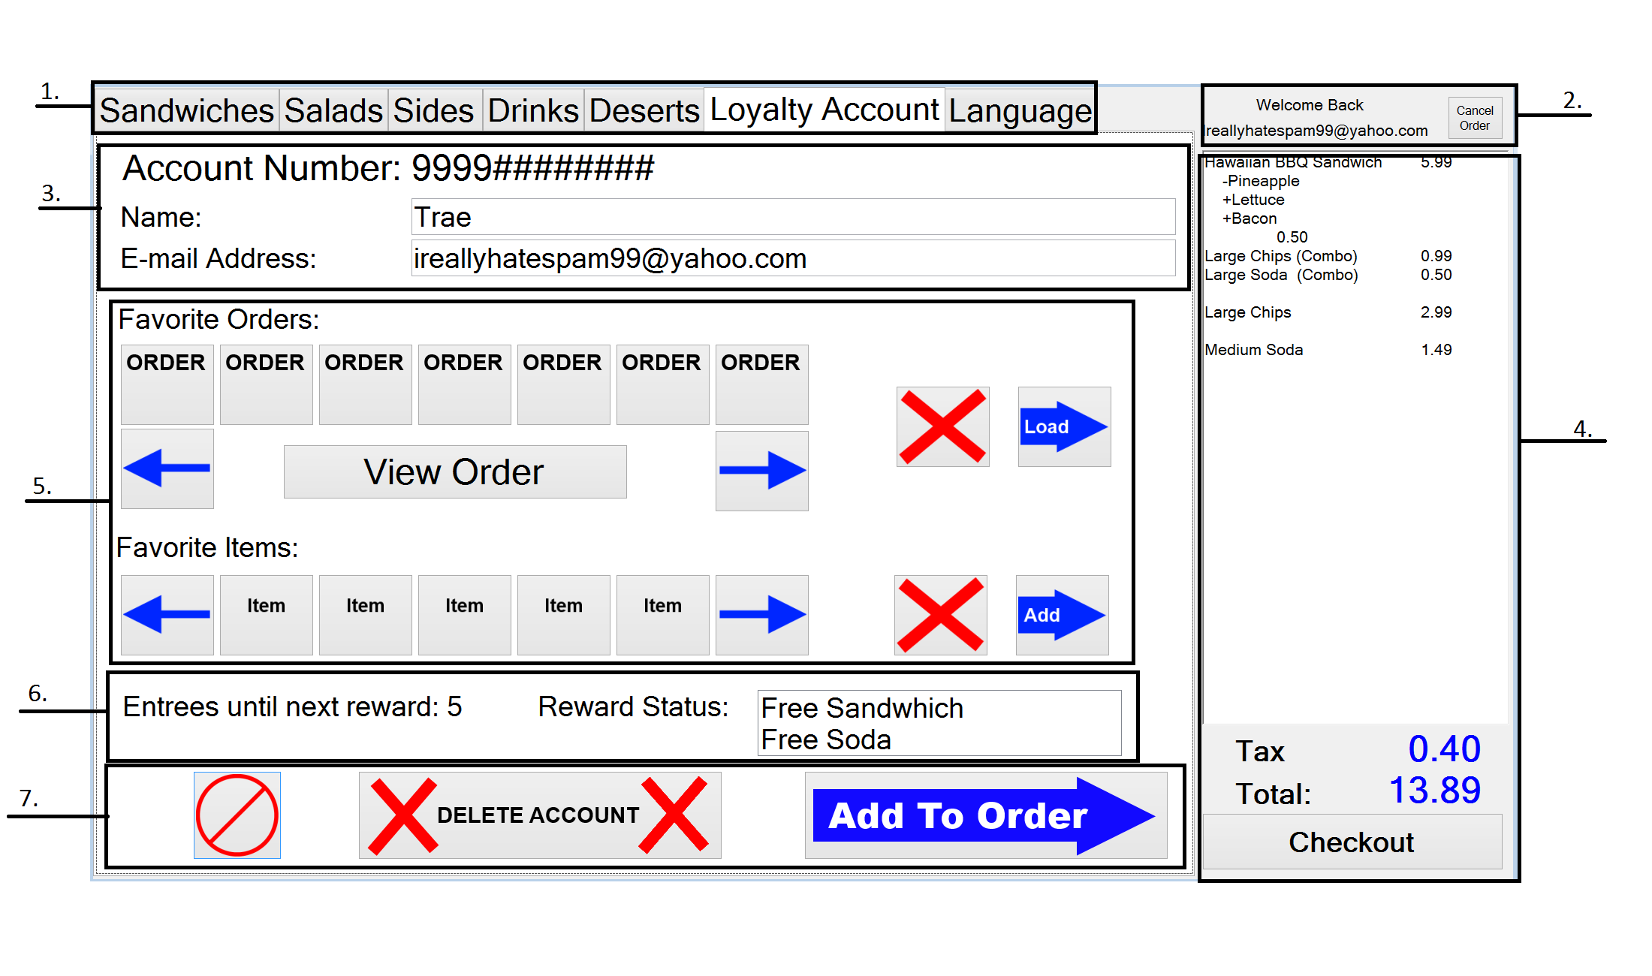

1. **Navigation Tab** – The navigation tab will allow customers to move between different menus within the order screen by pressing the corresponding tab.
2. **Identity Widget** – The identity widget only appears when the customer has logged into their loyalty account. The widget allows users to cancel their order and log out of their account. The widget displays the email address that is associated with the loyalty account used to log in.
3. **Loyalty Account Info** – This area is where the customer’s loyalty account information is displayed. The account number, name, and email address are displayed. The name and email address are the only information that can be changed.
4. **Receipt Bar** – The receipt bar keeps track of the items the customer has added to their order and the cost of the item. The receipt bar will update automatically when new items are added to the order. When the customer is finished with their order, the customer presses the “Checkout” button that sends the customer to the payment screen.
5. **Favorites Menu** – The favorites menu is where the customer’s 5 saved items and orders are displayed. The customer can add these favorites to their order by pressing the “Load/Add” buttons or delete them by clicking the “Remove” button.
6. **Loyalty Rewards Tracker** – The tracker shows the customer’s progress toward a loyalty award. The tracker shows the points remaining toward next reward as well as rewards that can be redeemed.
7. **Menu Action Buttons** – The menu action buttons allow the customer to add menu items to the order using the “Add To Order” button. The “Cancel” button will delete the order and return the customer to the startup screen. The “Delete Account” button ill allow customers to delete their loyalty accounts.

## Language Screen

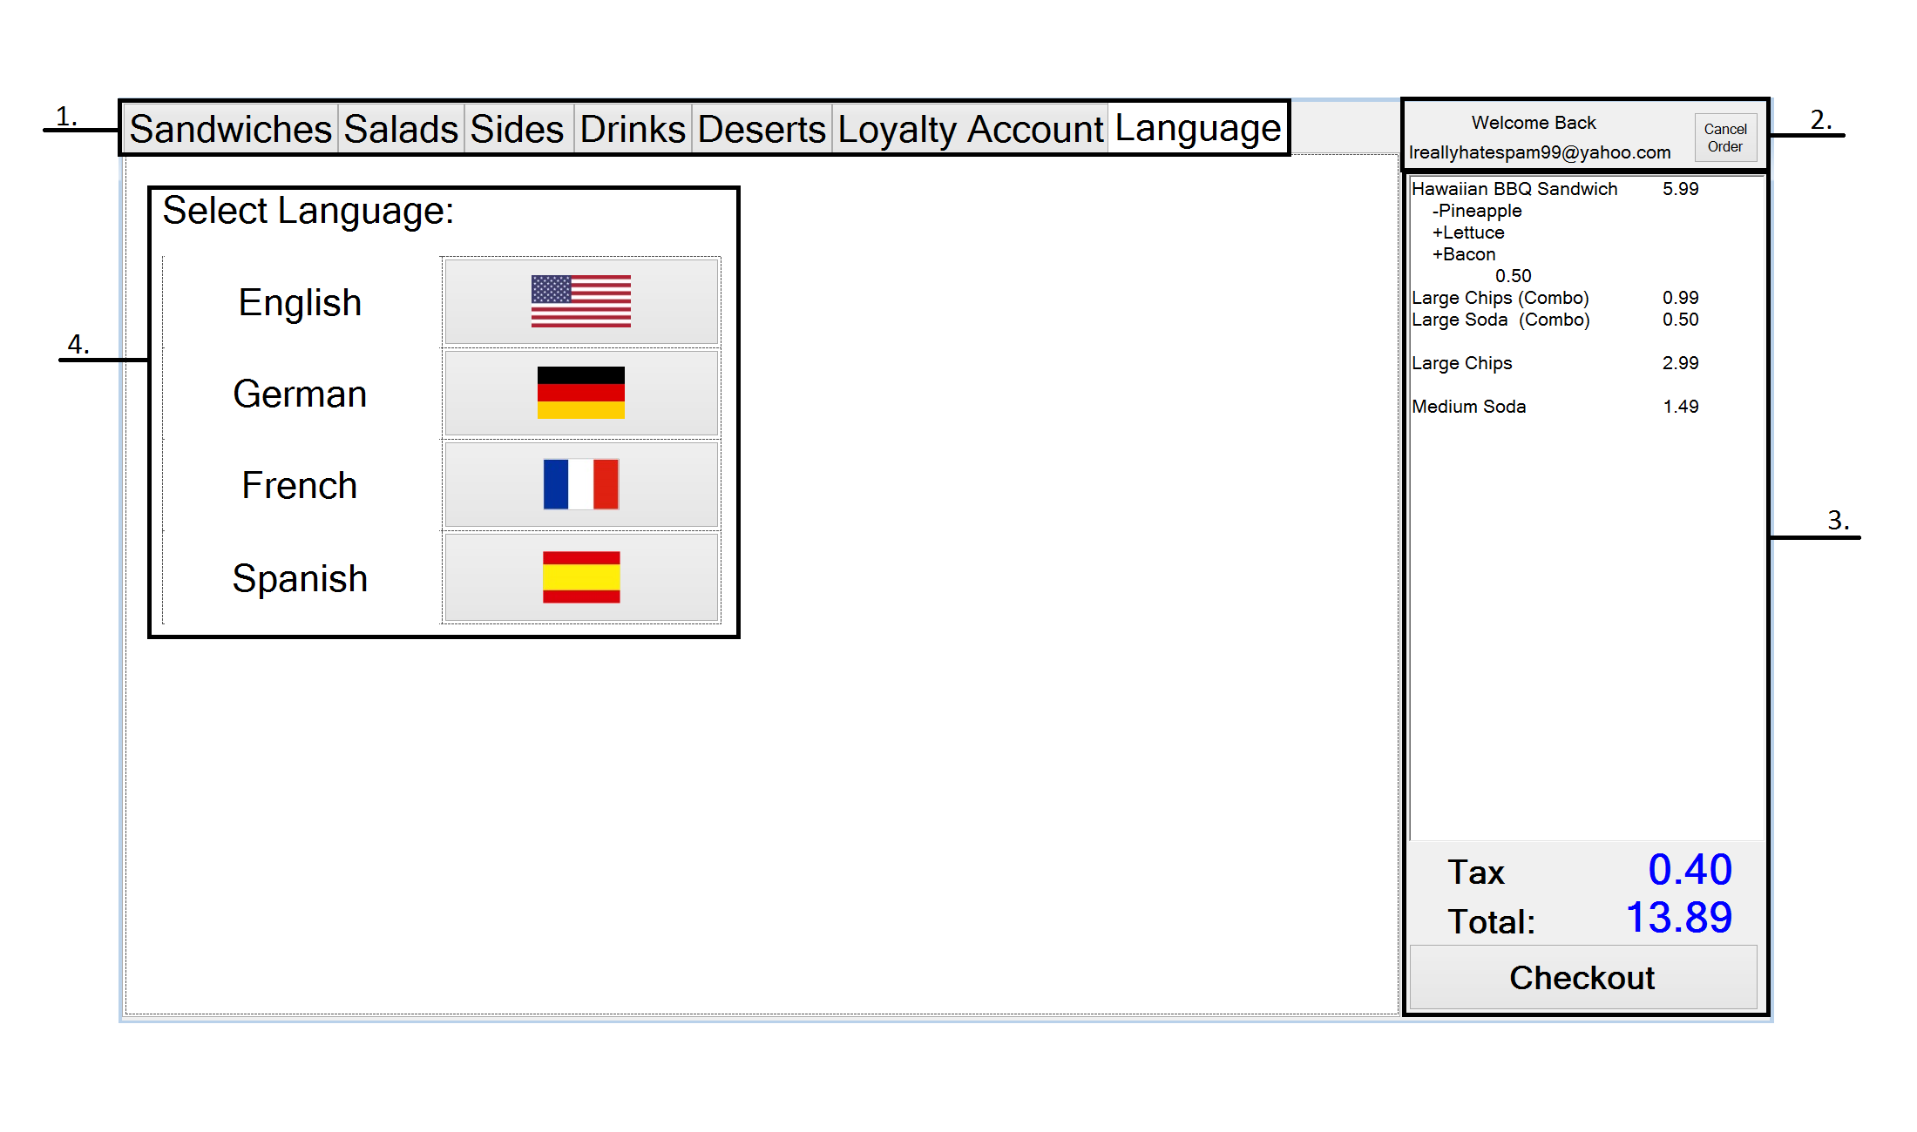

The language screen allows the customer to change the language of the text displayed on the terminal to a different language which they are more comfortable with.

1. **Navigation Tab** – The navigation tab will allow customers to move between different menus within the order screen by pressing the corresponding tab.
2. **Identity Widget** – The identity widget only appears when the customer has logged into their loyalty account. The widget allows users to cancel their order and log out of their account. The widget displays the email address that is associated with the loyalty account used to log in.
3. **Receipt Bar** – The receipt bar keeps track of the items the customer has added to their order and the cost of the item. The receipt bar will update automatically when new items are added to the order. When the customer is finished with their order, the customer presses the “Checkout” button that sends the customer to the payment screen.
4. **Language Menu** – The language menu will allow the customer to change the language of the text displayed to a different language if the language chosen at the startup screen was wrong.

# Manager Kiosk

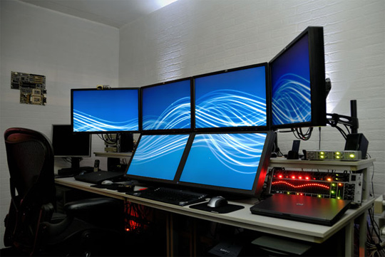

## Manager Order Screen

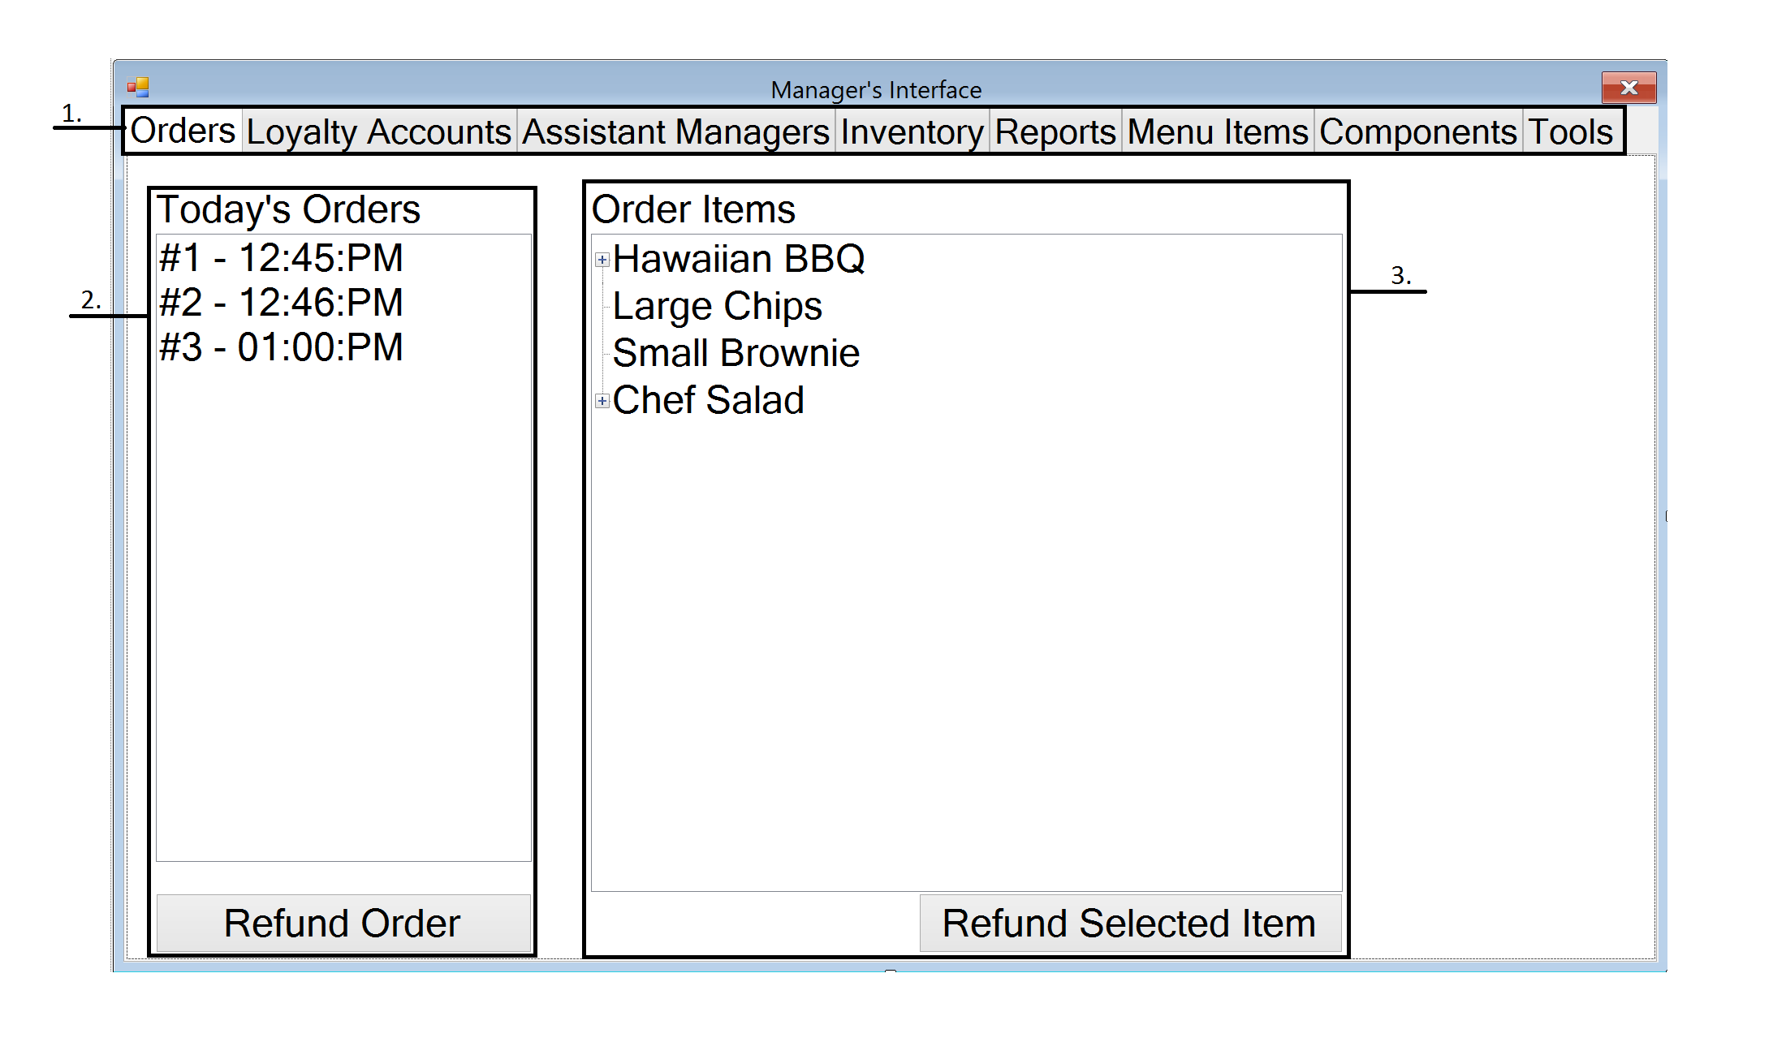

The orders screen on the manager’s kiosk allows the manager to view all the orders that have been paid for that day. The manager can use this screen to refund orders back to the customer or refund a specific item.

1. **Navigation Tab** – The navigation tab will allow managers to move between different menus within the order screen by pressing the corresponding tab.
2. **Store Orders List** – The list displays all of the customer orders at the store with their order number and time ordered. The manager can select the order and press the “Refund Order” button to refund an order if necessary.
3. **Order Items List** – The list displays all the components of the order currently selected. The manager can select an item in the order to refund by pressing the “Refund Selected Item” button.

## Manager Loyalty Account Screen

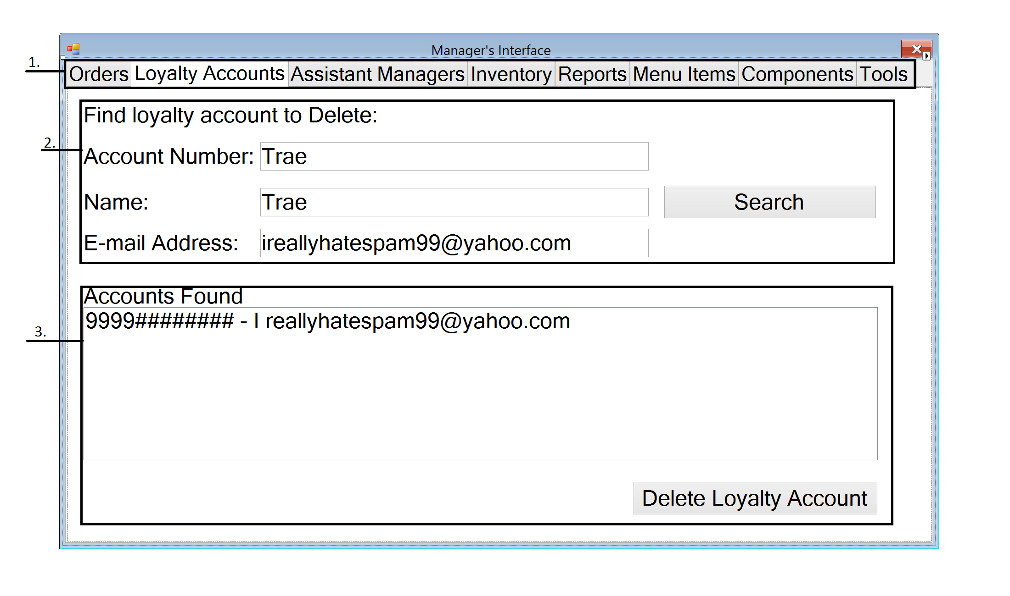

The loyalty account screen on the manager’s kiosk allows the manager to search through all the loyalty accounts created at the store. The manager can delete accounts at the customer request or find account information for a customer who has forgotten their account details.

1. **Navigation Tab** – The navigation tab will allow managers to move between different menus within the order screen by pressing the corresponding tab.
2. **Loyalty Account Search** – This search functionality will allow managers to search for accounts by account number, name, or email address. Managers can search for accounts to help customers who have forgotten their accounts.
3. **Loyalty Account Management** – This area lists the accounts that have been found using the search functionality. The manager can select one of the accounts listed and delete them using the “Delete Loyalty Account” button.

## Assistant Managers Screen

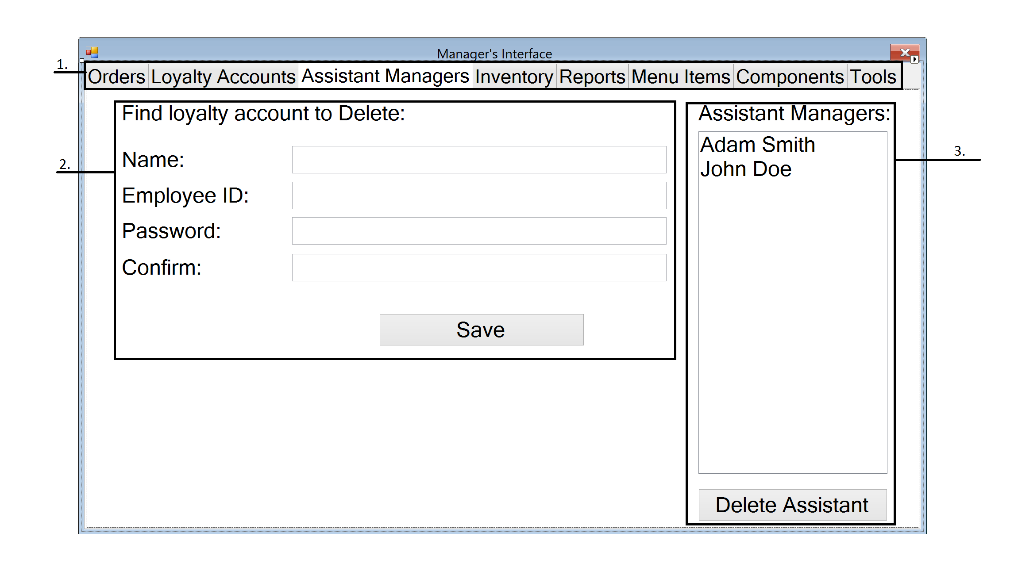

The assistant manager screen on the manager’s kiosk allows the store managers to create accounts for assistant managers so that they can log in and use the manager’s kiosk. Assistant managers can do all the same things as the store manager except add or delete assistant managers.

1. **Navigation Tab** – The navigation tab will allow managers to move between different menus within the order screen by pressing the corresponding tab.
2. **Assistant Managers Field** – Store managers may add assistant managers by filling out the form and hitting the “Save” button.
3. **Assistant Managers List** – Store managers may view all the store’s assistant managers and delete assistant manager accounts by selecting the name of the assistant manager and then pressing the “Delete Assistant” button.

## Manager Store Inventory Screen

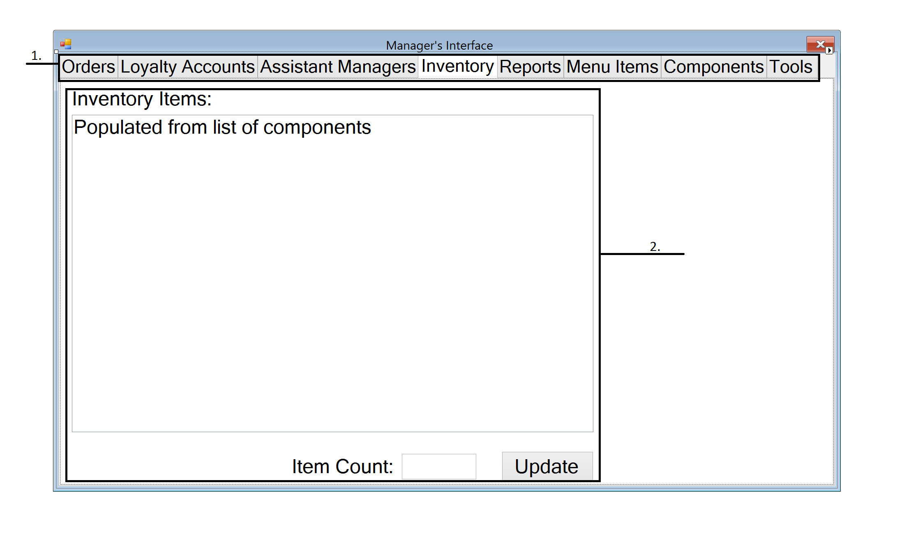

The inventory screen on the manager’s kiosk allows a manager to view the store’s current inventory. The manager can also update the quantity of each item in the inventory list.

1. **Navigation Tab** – The navigation tab will allow managers to move between different menus within the order screen by pressing the corresponding tab.
2. **Inventory List** – The inventory list will show the store’s inventory in a list that the manager can individually update.

## Manager Store Report Screen

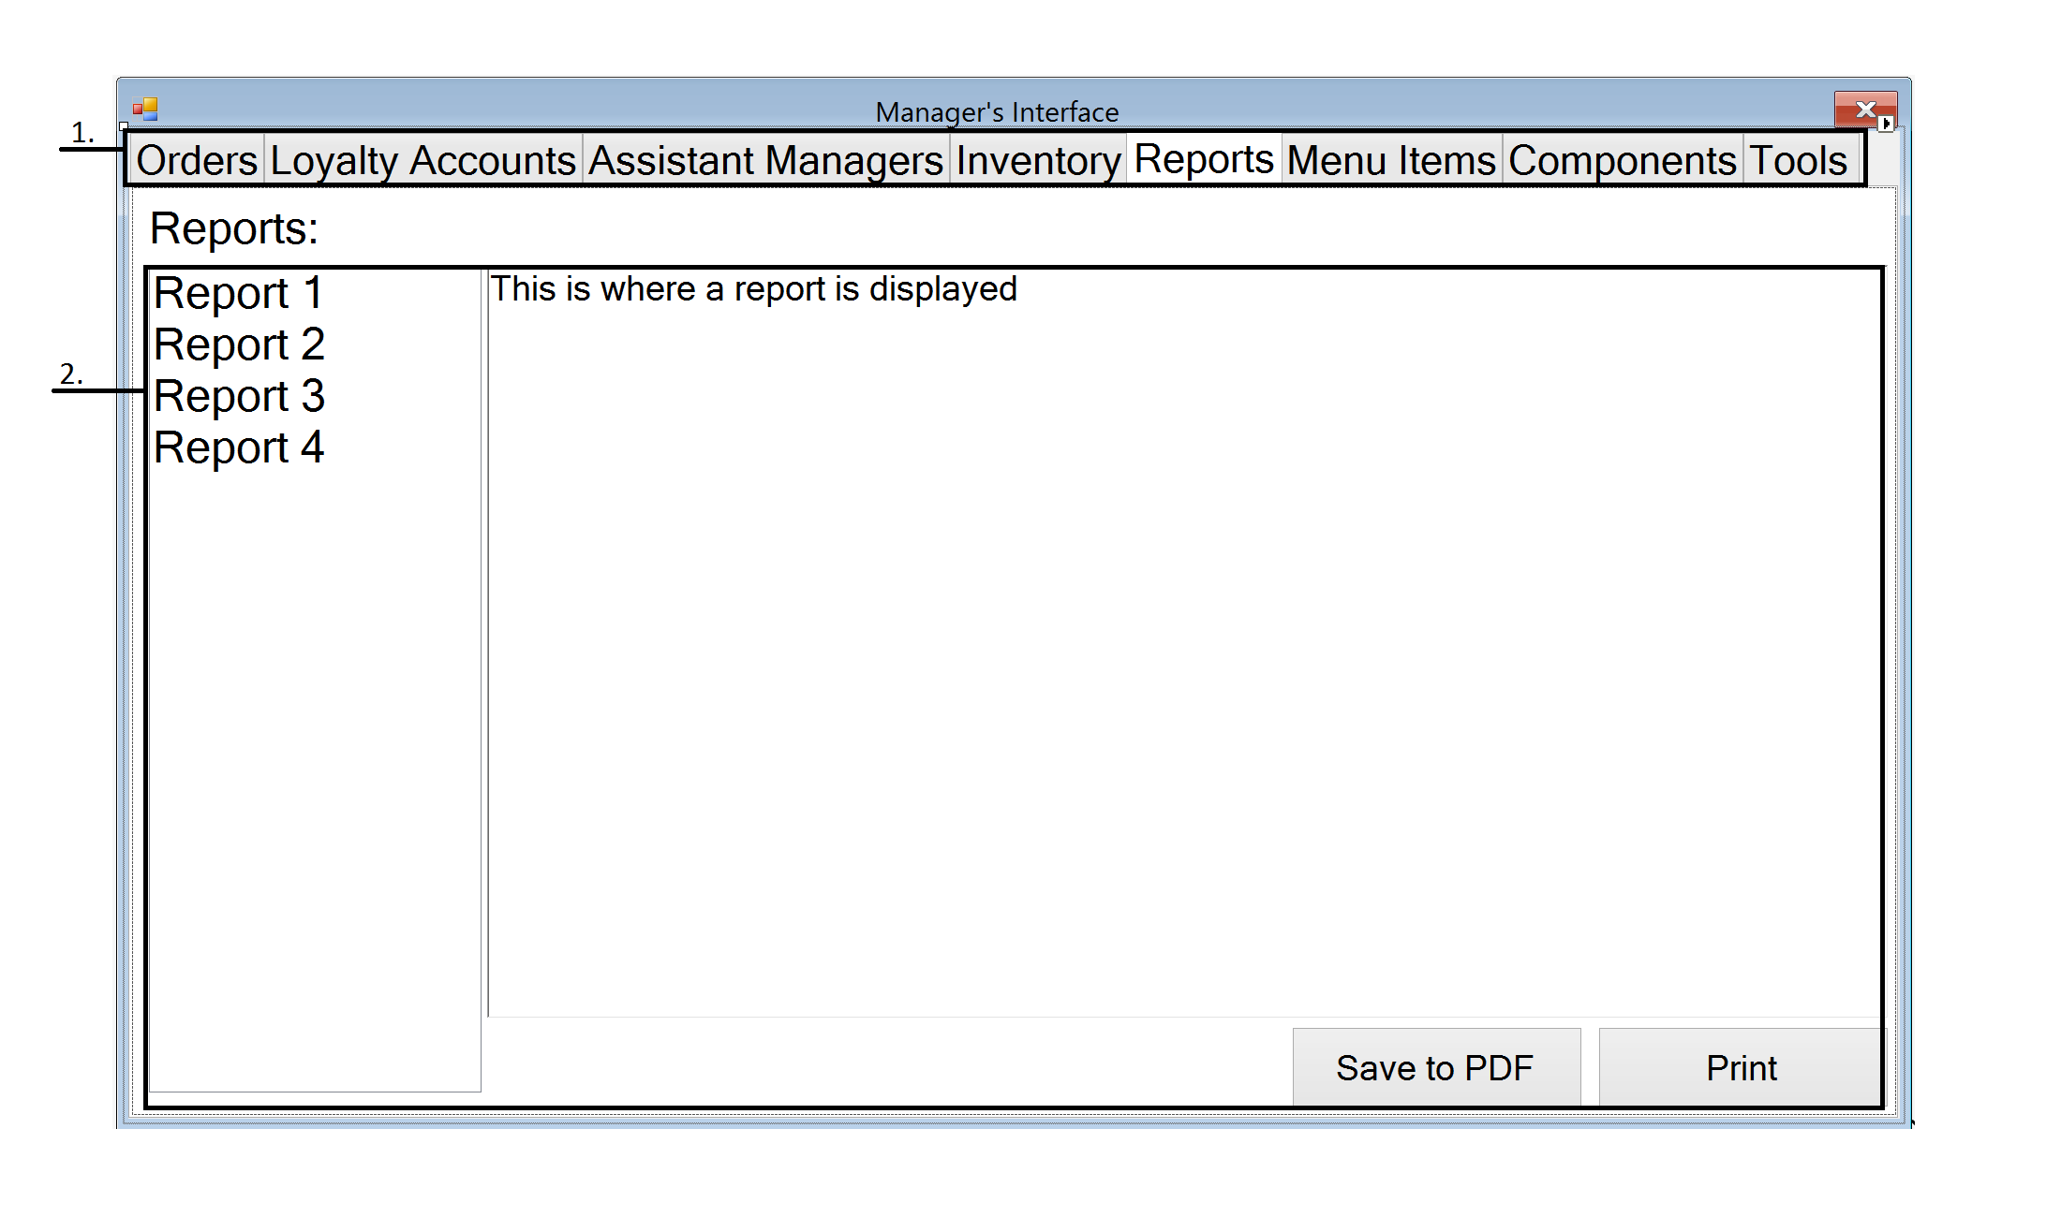

The store report screen on the manager kiosk lets managers view the reports that are automatically generated by the system. The managers can view each report in the screen, choose to save them to a PDF, or print the report out on paper.

1. **Navigation Tab** – The navigation tab will allow managers to move between different menus within the order screen by pressing the corresponding tab.
2. **Reports Log** – Reports are listed on the log automatically after each day and month. The managers can save the reports into PDF using the “Save to PDF” button or print out the reports using the “Print” button.

## Manager Menu Item Screen

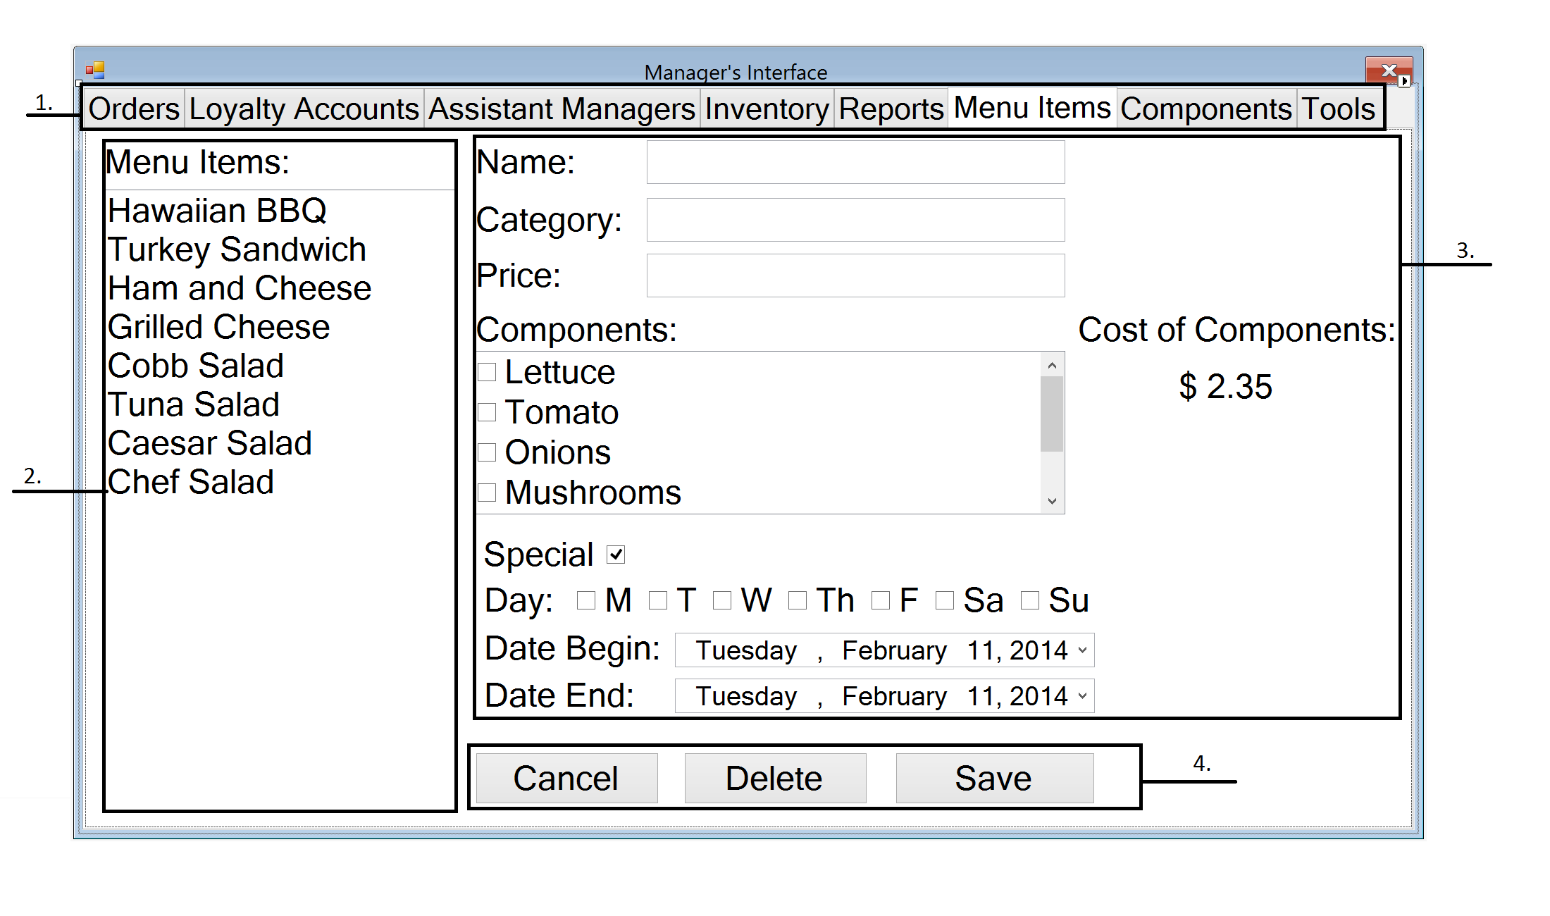

The manager menu item screen allows managers to create menu items that will be displayed on the customer’s kiosk to purchase. The manager can add, delete, or modify any menu item that is being sold in the store. The manager can also set a menu item as a special and define which days that it is offered and for how long.

1. **Navigation Tab** – The navigation tab will allow managers to move between different menus within the order screen by pressing the corresponding tab.
2. **Menu Items List** – The list displays all the current menu items being offered by the store. The managers can select individual items by pressing on each of their names.
3. **Menu Item Customizer** – In this menu the manager can customize menu items that he/she wishes to sell by entering the name of the item, the category it falls in, the price, and its components. If the manager makes the menu item a special, then the manager has to specify the days which the sandwich will be offered as a special and during what time period.
4. **Menu Action Buttons** – The menu action buttons allow the manager to add or delete menu items from the menu item list. To delete a menu item the manager must first select a menu item by pressing its name on the menu item list, then click the “Delete” button. To add a menu item the manager must fill out the menu item customizer, then click the “Save” button.

## Managers Component Screen

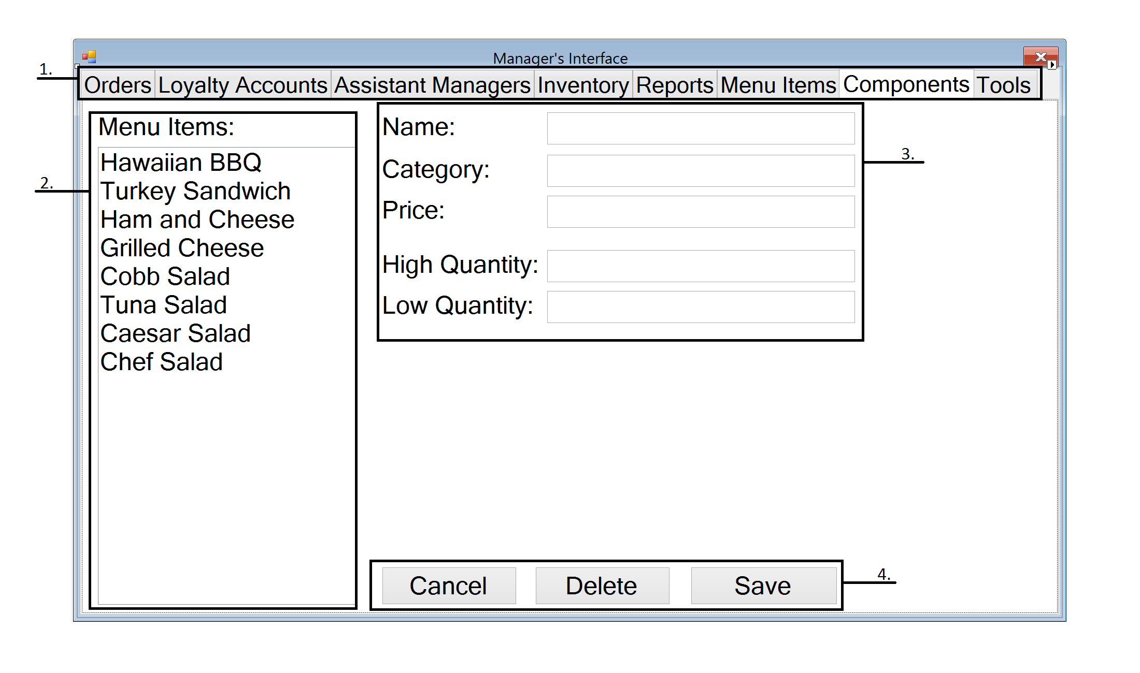

The manager component screen allows add, delete, or modify any ingredient that the store is offering customers. The manager has to define an ingredient by providing the name, category, price, and quantity before it is added to the system.

1. **Navigation Tab** – The navigation tab will allow managers to move between different menus within the order screen by pressing the corresponding tab.
2. **Component List** – The list displays all the current components being offered by the store as part of customizing a menu item. The managers can select individual items by pressing on each of their names.
3. **Component Creator** – In this menu the manager can create the components that he/she wishes to sell by entering the name of the component, the category it falls in, the price, and its quantity.
4. **Menu Action Buttons** – The menu action buttons allow the manager to add or delete components from the component list. To delete a component the manager must first select a component by pressing its name on the component list, then click the “Delete” button. To add a component the manager must fill out the component creator, then click the “Save” button.

## Manager Tool Screen

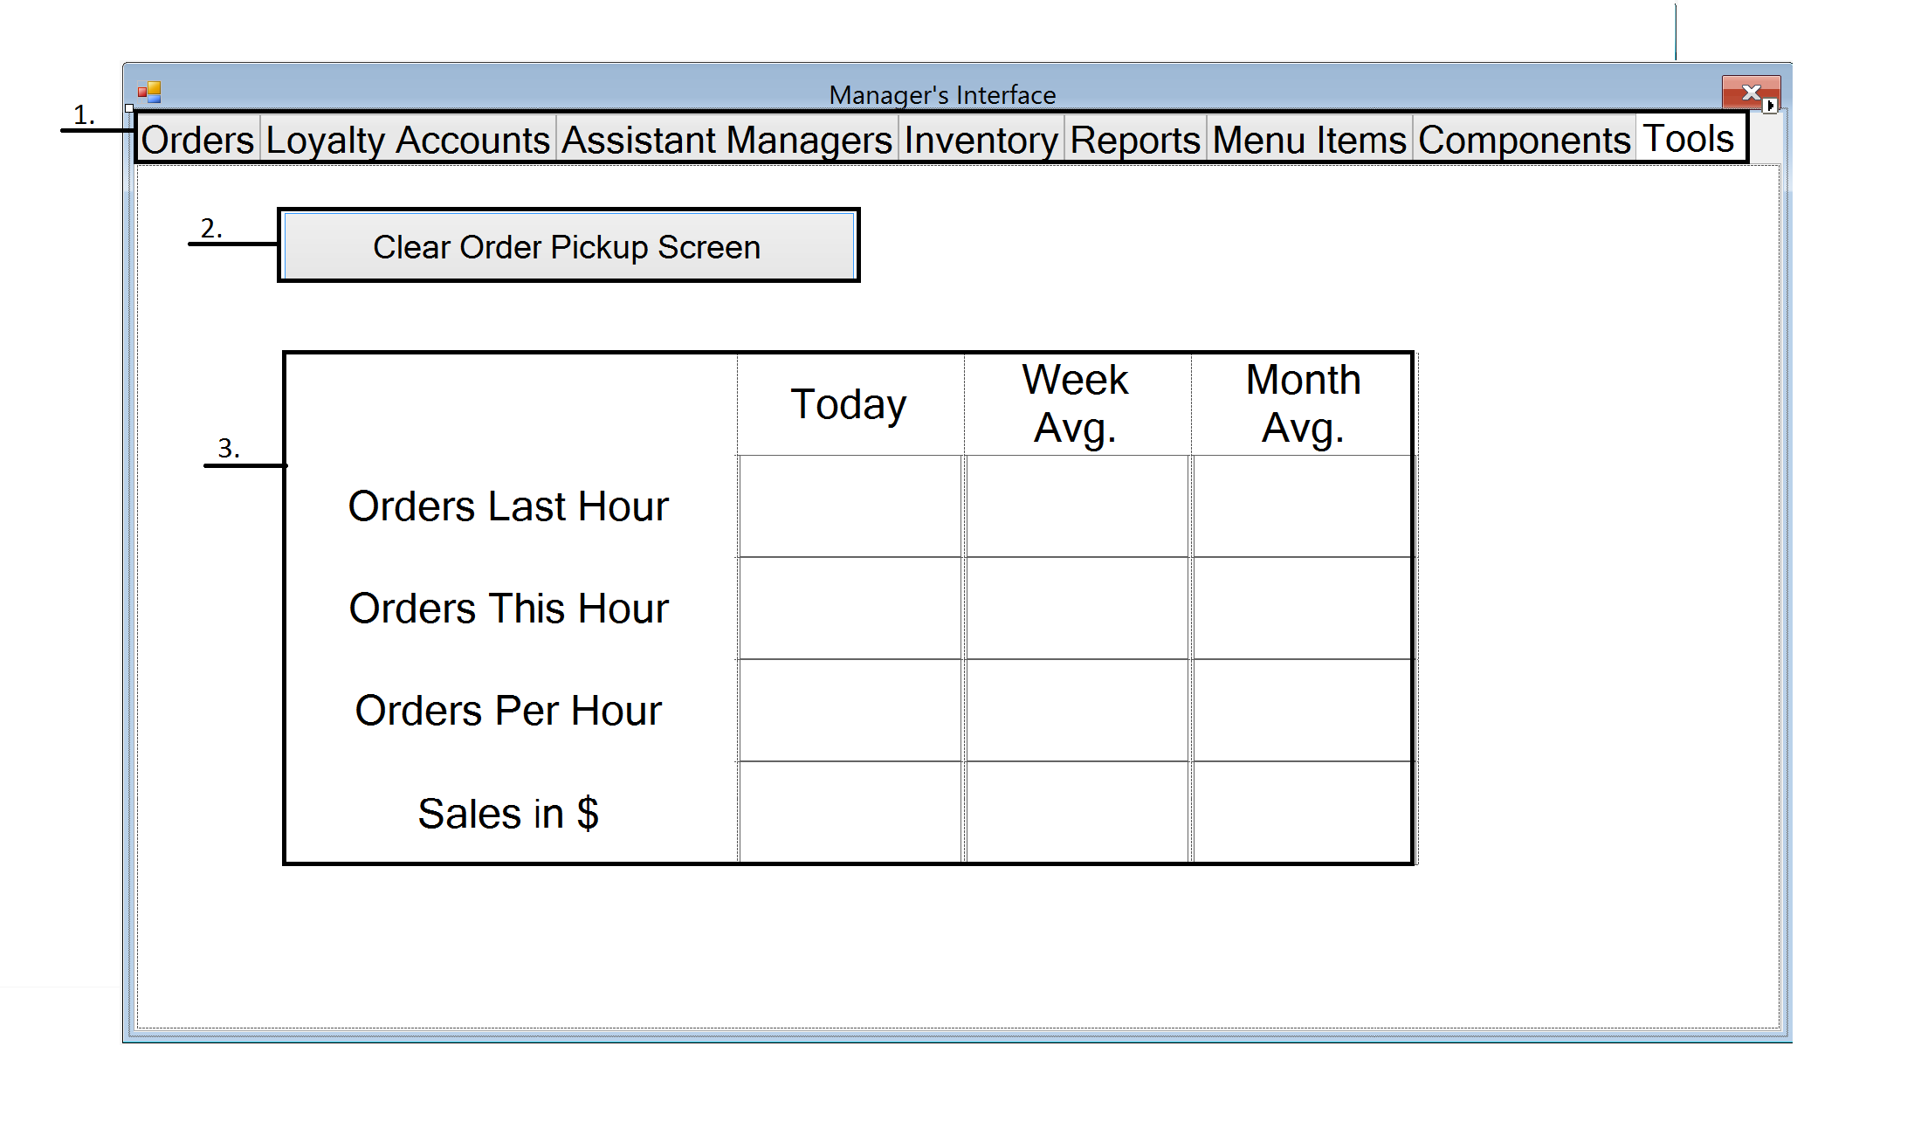

The manager tools screen provides two functions to the manager. It allows managers to clear order pickup screen in the dining area if there is nobody in the store or when closing. The second function this screen gives is the orders statistics that inform managers on how the store is doing by day, week, and month intervals.

1. **Navigation Tab** – The navigation tab will allow managers to move between different menus within the order screen by pressing the corresponding tab.
2. **Clear Order Pickup Screen** – The “Clear Order Pickup Screen” will allow the managers to clear all orders from the order pickup screen.
3. **Order Statistics** – This displays the statistics of the store for 4 statistics by day, week, and month.

# Corporate Kiosk



## Corporate Stores Screen

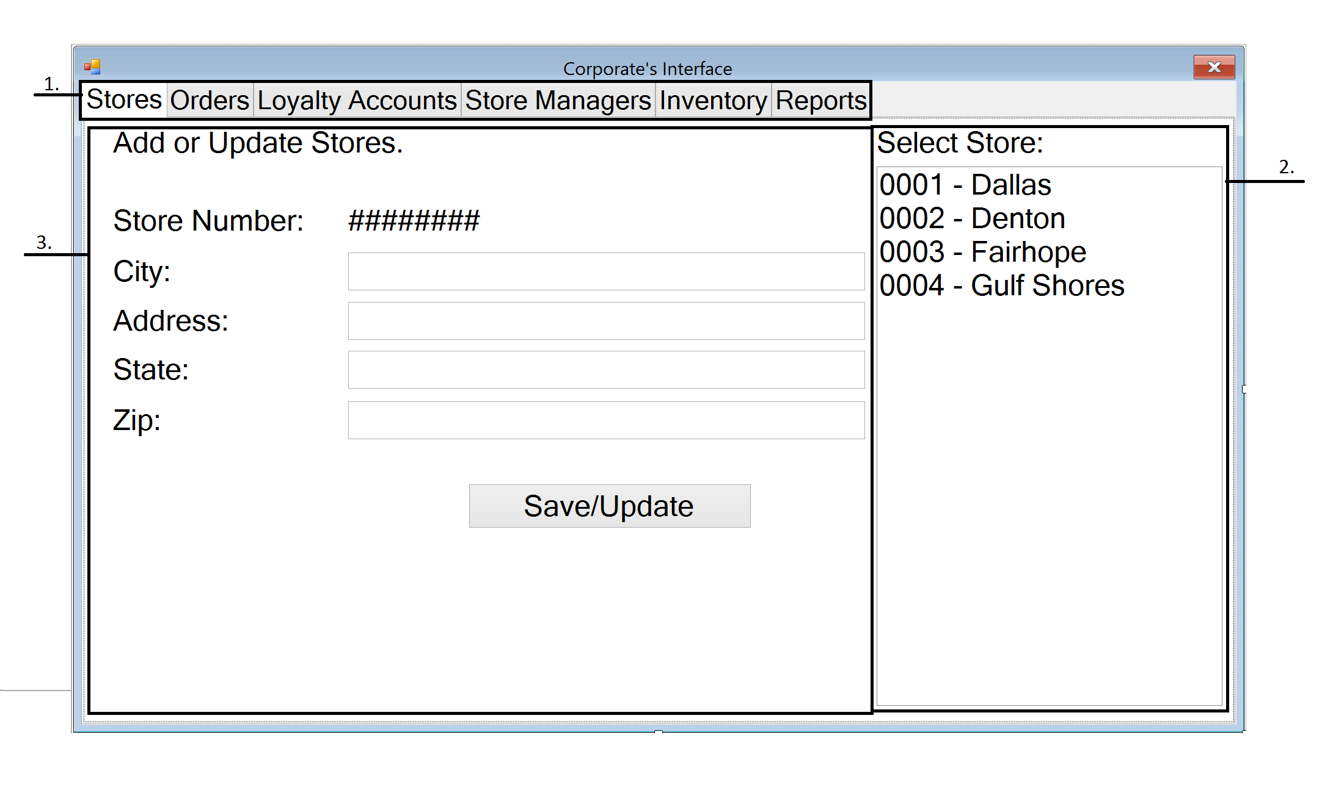

The corporate stores screen allows the corporation to add new stores into the system or modify information for existing stores in the system. The user must provide the address of the store to create a new store and the system will automatically generate the new store’s ID number.

1. **Navigation Tab** – The navigation tab will allow corporate users to move between different menus within the order screen by pressing the corresponding tab.
2. **Store List** – The store list displays all the stores in the chain organized by their store ID number with the older stores with lower numbers.
3. **Store Menu** – The menu will allow corporate users to add or update the information for new or existing stores in the chain. Store numbers are automatically assigned by the system based on the number of previous store while the Address of the store will have to be manually inputted.

## Corporate Orders Screen

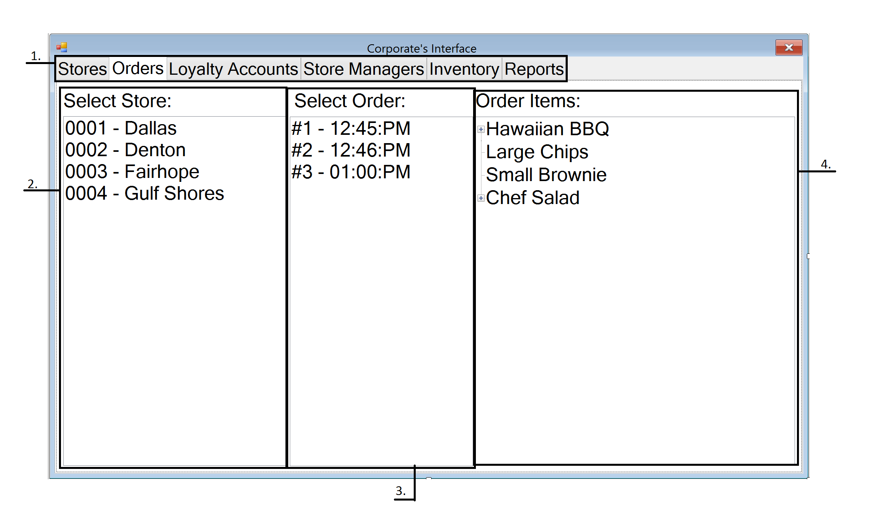

The corporate orders screen allows the corporation to view all the orders paid in each store for the last business day. The screen allows the corporation to see which stores have the most traffic and make the most money. The corporation can view the specific items that are sold in each order to see what items are the most popular.

1. **Navigation Tab** – The navigation tab will allow corporate users to move between different menus within the order screen by pressing the corresponding tab.
2. **Store List** – The corporate user can select a store by pressing its name in the store list and it will populate the order list with the day’s orders for the selected store.
3. **Orders List** – The list is populated when a user selects a store from the store list to the left. Orders can be selected to populate the orders items to display all the items ordered.
4. **Order Item List** – The list is populated when a user selects an order from the orders list to the left.

## Corporate Loyalty Account Screen

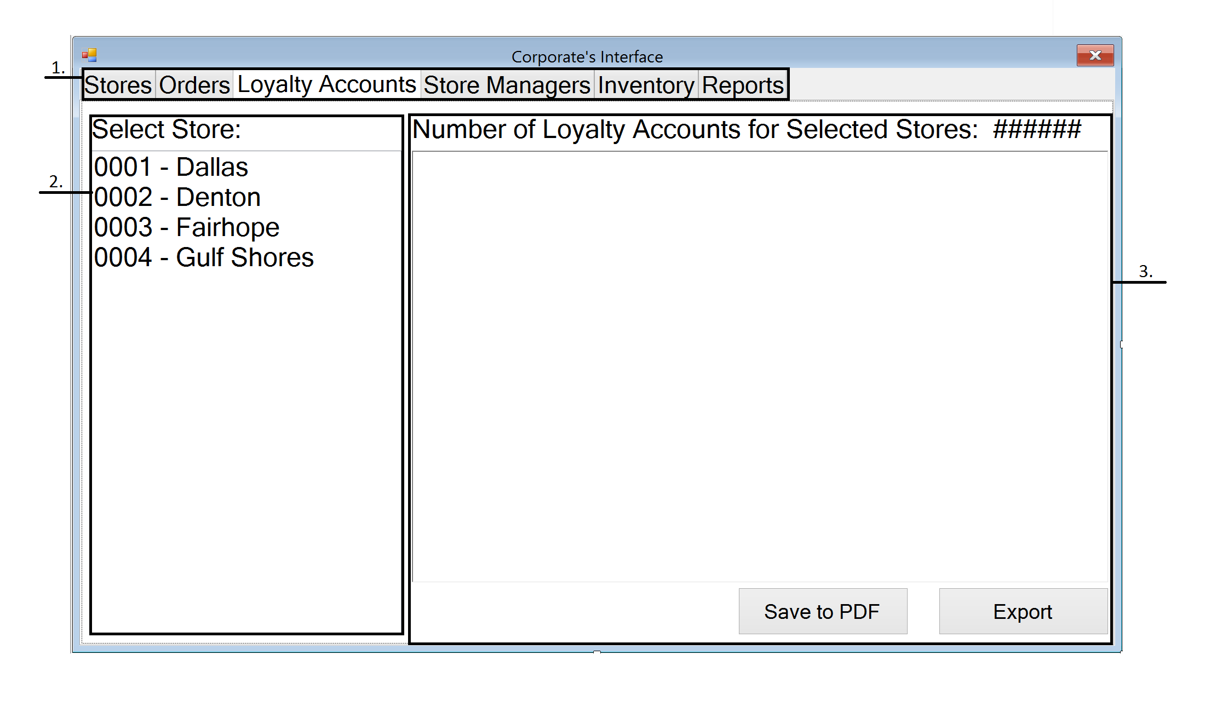

The corporate loyalty account screen allows the corporation to view the number of loyalty accounts that have been created at each store. The system will list all the accounts for each store by their ID number with the email associated with it. The corporation can save the list to a PDF or export it somewhere else.

1. **Navigation Tab** – The navigation tab will allow corporate users to move between different menus within the order screen by pressing the corresponding tab.
2. **Store List** – The corporate user can select a store by pressing its name in the store list and it will populate the loyalty account list with the loyalty accounts created at the selected store.
3. **Loyalty Account List** - The list is populated when a user selects a store from the store list to the left. The list of loyalty accounts can be saved to PDF or exported into a text file.

## Corporate Store Manager Screen

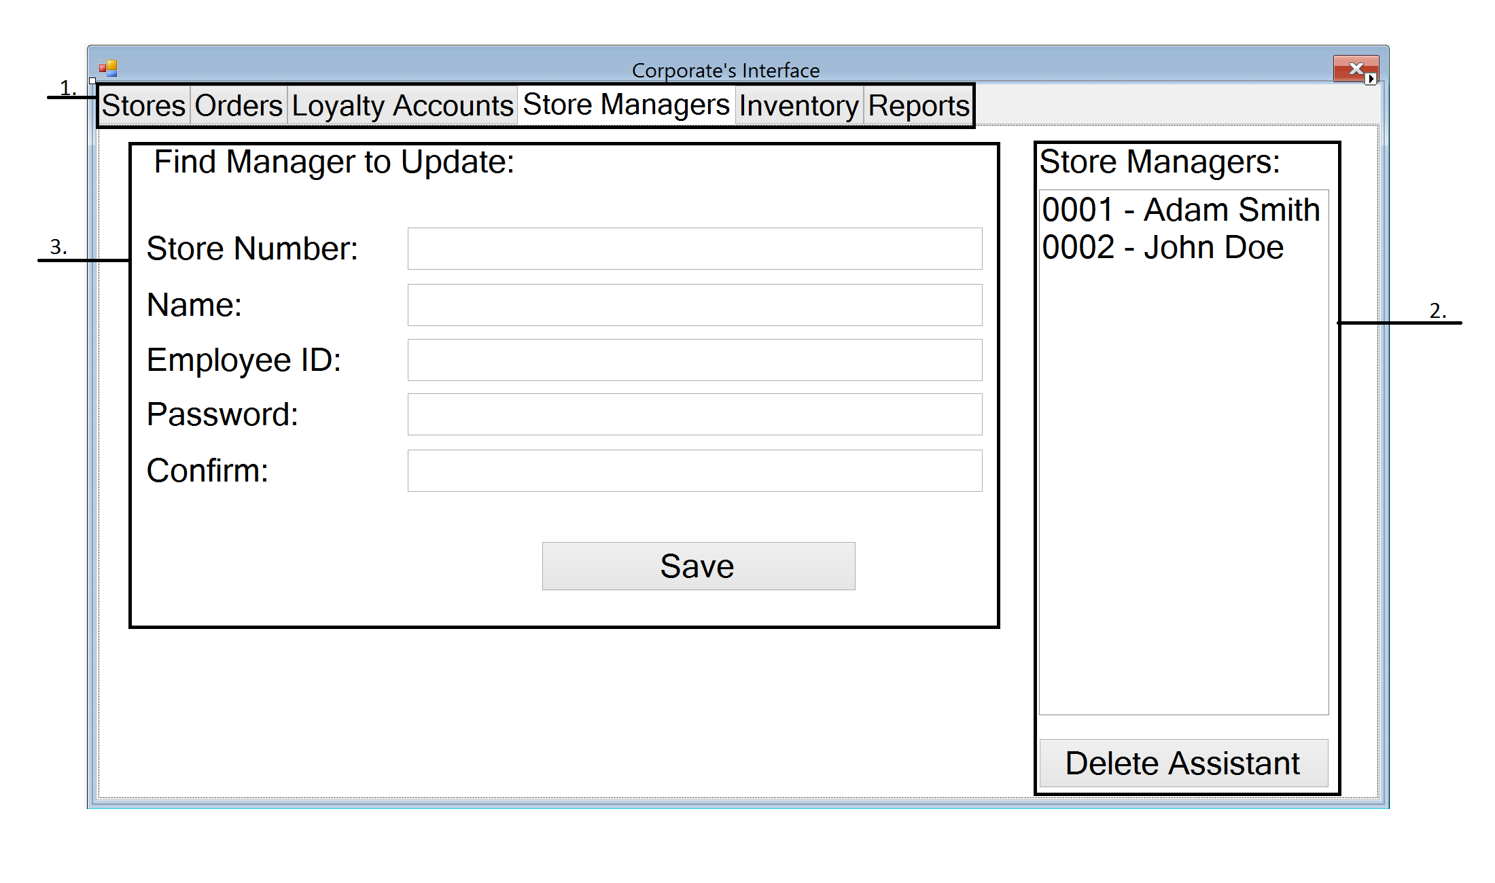

The store manager screen allows the corporation to make changes to the store managers working at each store. The corporation create the special store manager accounts for each store and can modify which store that the manager’s account is valid. This allows corporate users to easily transfer upper level employees between locations.

1. **Navigation Tab** – The navigation tab will allow corporate users to move between different menus within the order screen by pressing the corresponding tab.
2. **Store Managers List** – The list shows all the store managers currently employed in the chain. Selecting a store manager will populate the manager information menu to the left allowing corporate users to edit the employee’s information. The user can delete managers by selecting a manager on the list and pressing the “Delete Assistant” button.
3. **Manager Information Menu** - The list is populated when a user selects a manager from the store managers list to the right. If the list has not been populated by selecting a manager from the store managers list, then when the information is saved a new store manager account is created.

## Corporate Reports Screen

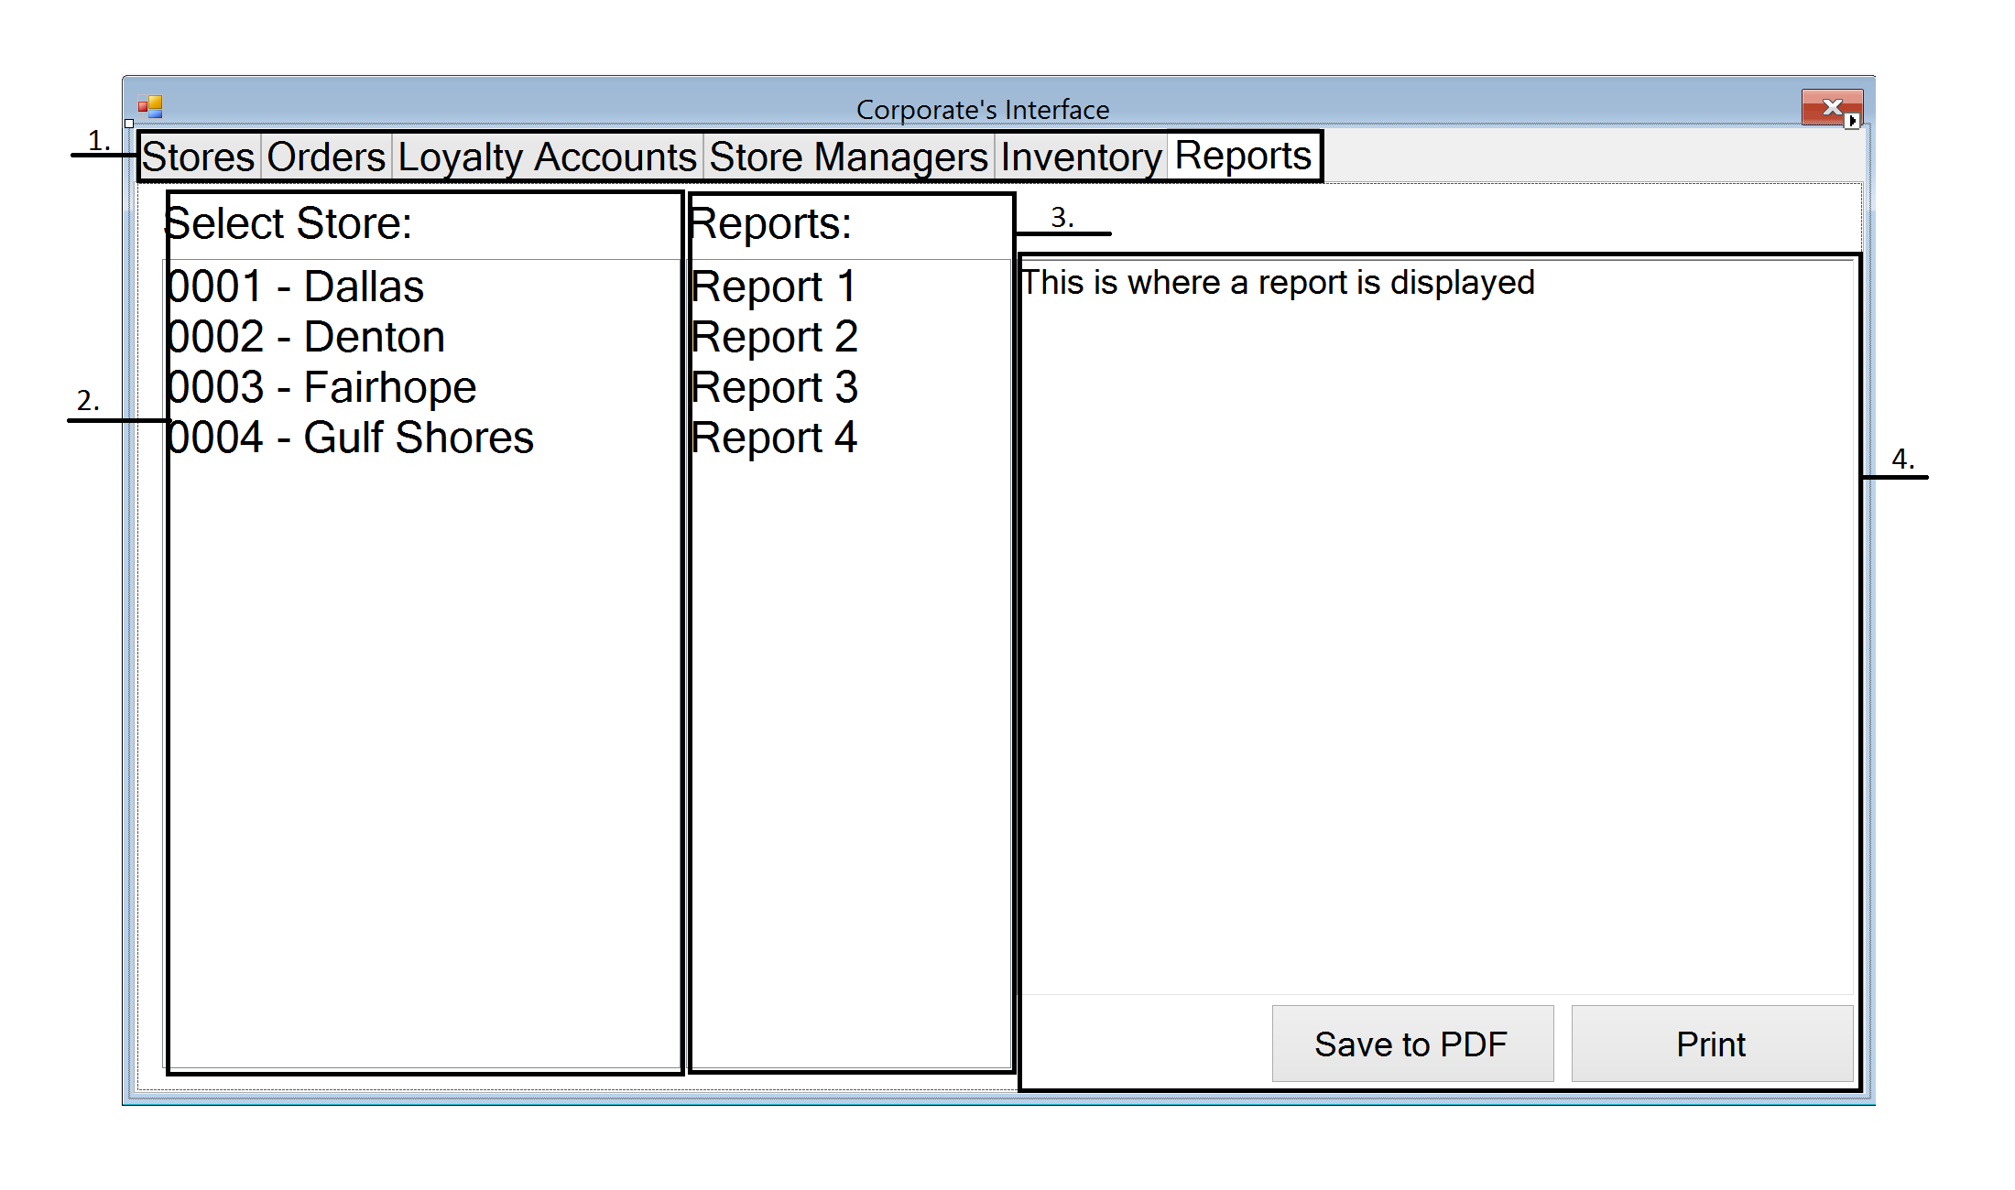

The reports screen on the corporate terminal takes copies of the reports created at each store location and allows the corporation to view reports at each location. Similarly to the manager’s kiosk, the corporate user can view the report, save it to a PDF, or print out the report.

1. **Navigation Tab** – The navigation tab will allow corporate users to move between different menus within the order screen by pressing the corresponding tab.
2. **Store List** – The corporate user can select a store by pressing its name in the store list and it will populate the reports list with the reports at the selected store.
3. **Reports List** - The list is populated when a user selects a store from the store list to the left. The user can select a report from the list and it will be displayed on the report panel to the right.
4. **Report Panel** – The panel is populated when a report is selected from the reports list to view the contents list. The report can also be saved to a PDF or printed by pressing the buttons below.

# Other Terminals

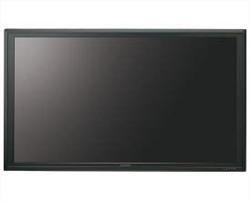

## Kitchen Terminal Screen

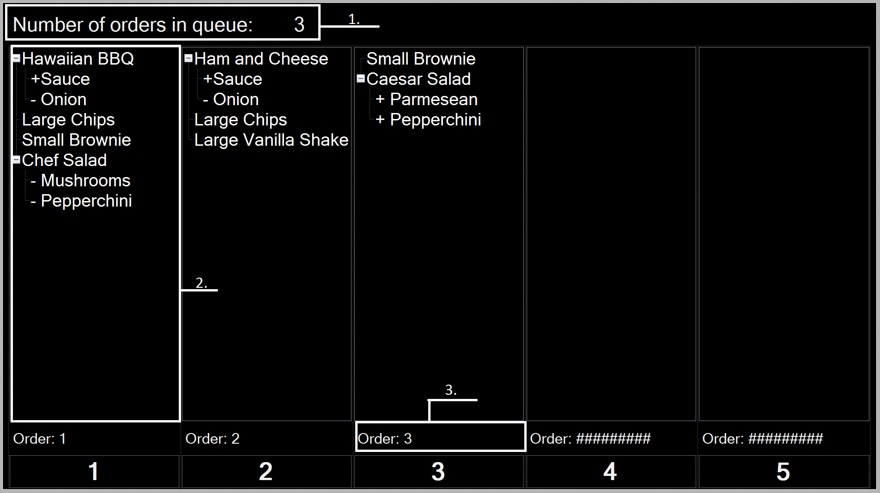

The kitchen terminal screen displays orders that have been paid at the customer kiosk that are waiting to be prepared. The screen displays the number of orders in queue beyond the 5 shown on screen at the top left of the screen. When an order is completed, the kitchen staff presses the button corresponding to one of the 5 shown on screen and the order is removed from the screen and the order number is displayed on the dining area terminal to inform the customer to pick up the order.

1. **Orders Tracker** – This displays the number of orders that have arrived at the kitchen but not yet completed. The terminal will only display 5 orders so this gives employees awareness of the pace they need to be working.
2. **Order Information** – This panel displays the items within the order that the kitchen must prepare. When the order is marked as completed, the order is removed from this screen.
3. **Order Number** – This is the order number associated with the order being displayed above. When the order is complete the order number, is sent to the dining area terminal to inform the customer that their order has been prepared.

## Dining Area Terminal

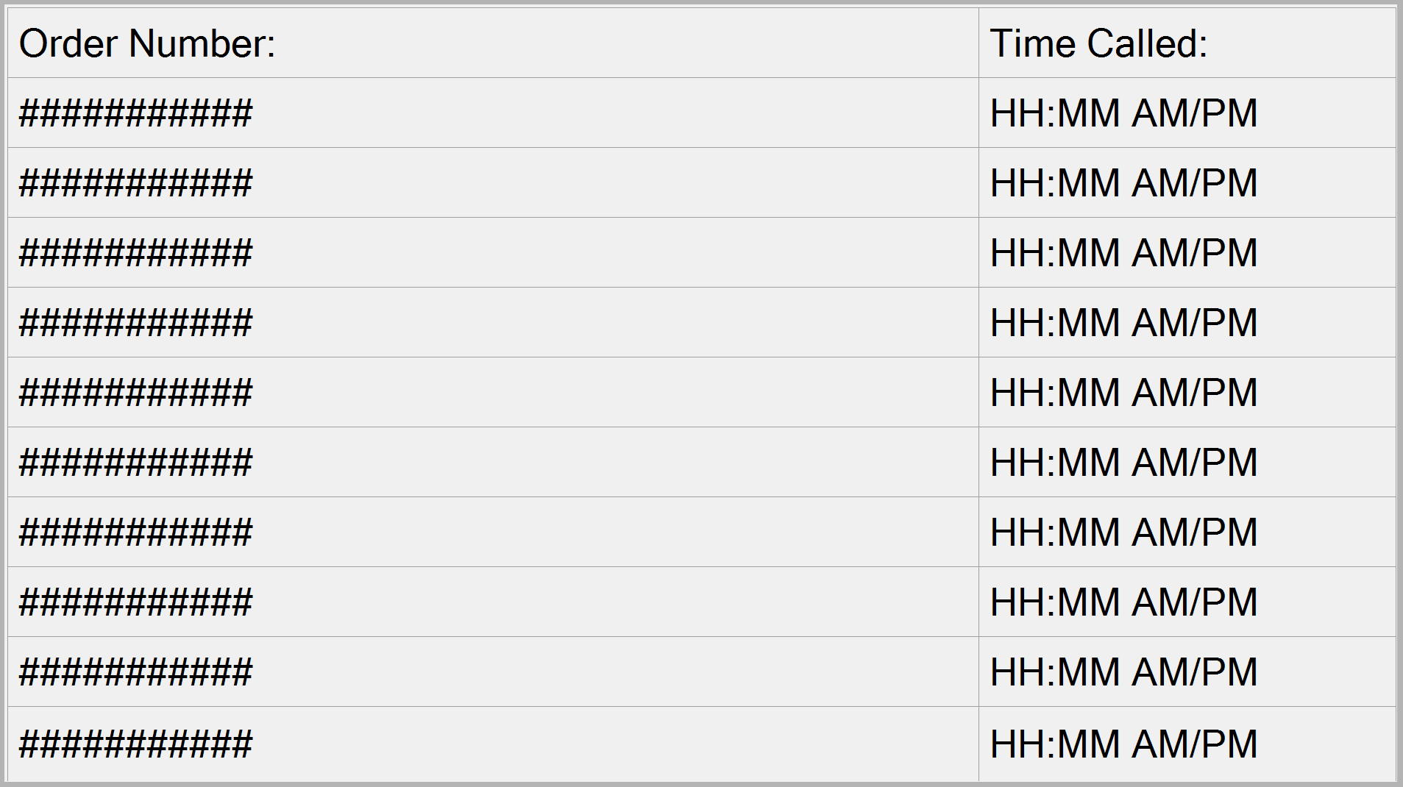

This is what the Dining Area Terminal displays to the customers. When an order is competed by the kitchen, the order number is displayed on this terminal. The time when the order is completed is also displayed next to the order number in order to prevent any confusion. The display only shows the last 10 orders completed. If the display is full, a new order replaces the oldest order in the list. Any orders still on the screen after 20 minutes is automatically removed.